SQL SERVER CASE STUDY

CREATE TABLE regions (

region_id INTEGER primary key,

region_name VARCHAR(9)

);

INSERT INTO regions (region_id, region_name) VALUES

('1', 'Australia'),

('2', 'America'),

('3', 'Africa'),

('4', 'Asia'),

('5', 'Europe');

CREATE TABLE customer_nodes (

customer_id INTEGER,

CONSTRAINT "FK_CUSTNODES_custid" FOREIGN KEY ("customer_id") REFERENCES "dbo"."customer_transactions"("customer_id"),

region_id INTEGER,

CONSTRAINT "FK_CUSTNODES_regionid" FOREIGN KEY ("region_id") REFERENCES "dbo"."regions"("region_id"),

node_id INTEGER,

start_date DATE,

end_date DATE

);

INSERT INTO customer_nodes

(customer_id, region_id, node_id, start_date, end_date) VALUES

('429', '3', '4', '2020-01-02', '2020-01-03'),

('155', '3', '5', '2020-01-03', '2020-01-17'),

('398', '5', '4', '2020-01-27', '2020-02-18'),

('255', '5', '4', '2020-01-07', '2020-01-19'),

('185', '3', '3', '2020-01-15', '2020-01-23'),

('309', '1', '1', '2020-01-11', '2020-02-06'),

('312', '2', '5', '2020-01-20', '2020-02-04'),

('376', '1', '2', '2020-01-15', '2020-01-28'),

('188', '4', '5', '2020-01-21', '2020-01-25'),

('138', '3', '4', '2020-01-13', '2020-01-14'),

('373', '2', '5', '2020-01-19', '2020-01-25'),

('361', '1', '2', '2020-01-13', '2020-01-14'),

('169', '2', '3', '2020-01-02', '2020-01-14'),

('402', '1', '2', '2020-01-25', '2020-01-25'),

('60', '1', '3', '2020-01-25', '2020-02-08'),

('378', '4', '4', '2020-01-13', '2020-01-18'),

('383', '2', '3', '2020-01-19', '2020-01-27'),

('292', '1', '3', '2020-01-17', '2020-02-15'),

('63', '2', '2', '2020-01-17', '2020-02-06'),

('499', '2', '4', '2020-01-18', '2020-02-09'),

('130', '3', '4', '2020-01-04', '2020-01-14'),

('130', '3', '3', '2020-01-18', '2020-02-09'),

('441', '5', '5', '2020-02-19', '2020-03-06'),

('53', '5', '4', '2020-01-20', '2020-02-13'),

('30', '3', '1', '2020-01-24', '2020-01-30'),

('429', '1', '1', '2020-02-07', '2020-02-29'),

('155', '2', '4', '2020-02-05', '2020-02-20'),

('398', '1', '1', '2020-01-29', '2020-02-12'),

('255', '4', '4', '2020-01-26', '2020-02-03'),

('185', '3', '1', '2020-01-15', '2020-01-30'),

('309', '2', '3', '2020-01-26', '2020-01-30'),

('312', '1', '2', '2020-01-15', '2020-01-17'),

('376', '2', '4', '2020-01-15', '2020-01-24'),

('188', '1', '1', '2020-01-26', '2020-02-04'),

('138', '1', '1', '2020-02-09', '2020-02-23'),

('373', '4', '2', '2020-01-19', '2020-02-16'),

('361', '2', '2', '2020-01-28', '2020-02-23');

CREATE TABLE customer_transactions (

customer_id INTEGER primary key,

txn_date DATE,

txn_type VARCHAR(10),

txn_amount INTEGER

);

INSERT INTO customer_transactions (customer_id, txn_date, txn_type, txn_amount) VALUES

('429', '2020-01-21', 'deposit', '82'),

('155', '2020-01-10', 'deposit', '712'),

('398', '2020-01-01', 'deposit', '196'),

('255', '2020-01-14', 'deposit', '563'),

('185', '2020-01-29', 'deposit', '626'),

('309', '2020-01-13', 'deposit', '995'),

('312', '2020-01-20', 'deposit', '485'),

('376', '2020-01-03', 'deposit', '706'),

('188', '2020-01-13', 'deposit', '601'),

('138', '2020-01-11', 'deposit', '520'),

('373', '2020-01-18', 'deposit', '596'),

('361', '2020-01-12', 'deposit', '797'),

('169', '2020-01-10', 'deposit', '628'),

('402', '2020-01-05', 'deposit', '435'),

('60', '2020-01-19', 'deposit', '495'),

('378', '2020-01-07', 'deposit', '193'),

('383', '2020-01-26', 'deposit', '889'),

('292', '2020-01-10', 'deposit', '136'),

('63', '2020-01-06', 'deposit', '234'),

('499', '2020-01-02', 'deposit', '147'),

('130', '2020-01-02', 'deposit', '557'),

('441', '2020-01-12', 'deposit', '418'),

('53', '2020-01-24', 'deposit', '22'),

('30', '2020-01-26', 'deposit', '33');

ER DIAGRAM

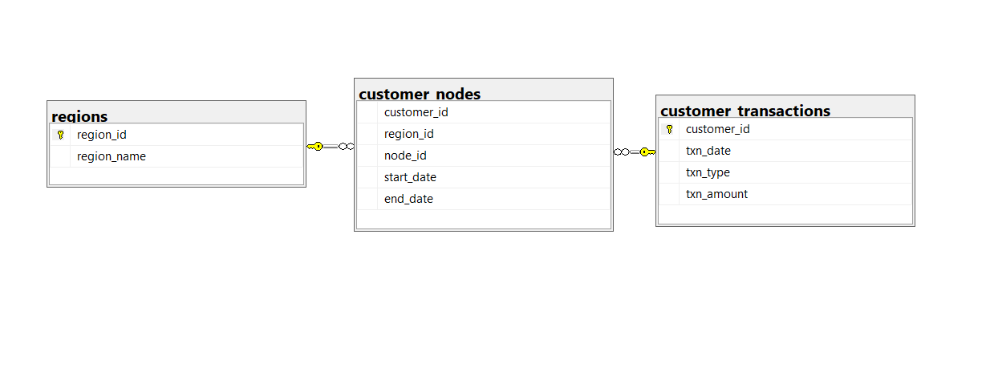

Q1. How many unique nodes are there on the Data Bank system?

select count(distinct node_id) unique_nodes from customer_nodes;

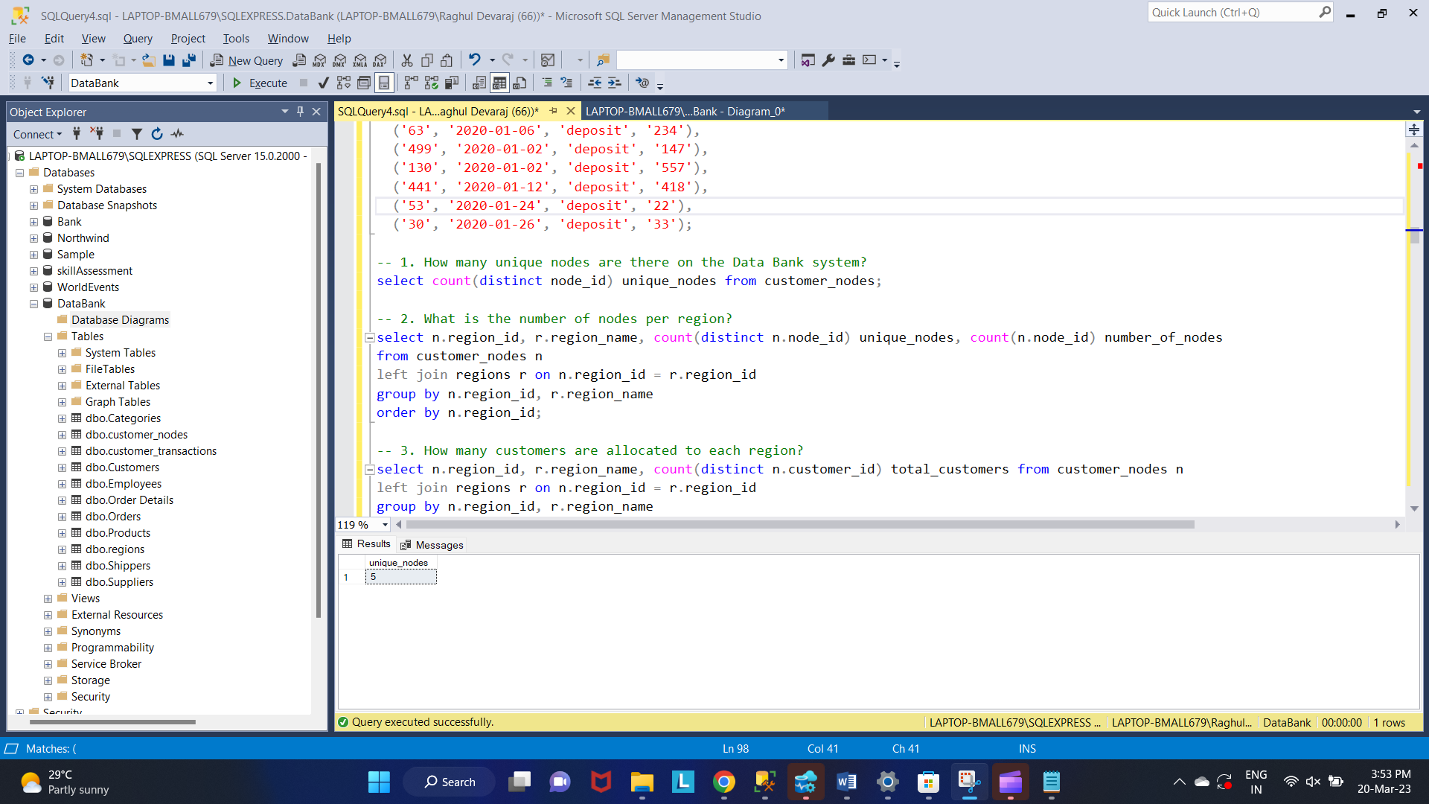

Q2. What is the number of nodes per region?

select n.region_id, r.region_name, count(distinct n.node_id) unique_nodes, count(n.node_id) number_of_nodes

from customer_nodes n

left join regions r on n.region_id = r.region_id

group by n.region_id, r.region_name

order by n.region_id;

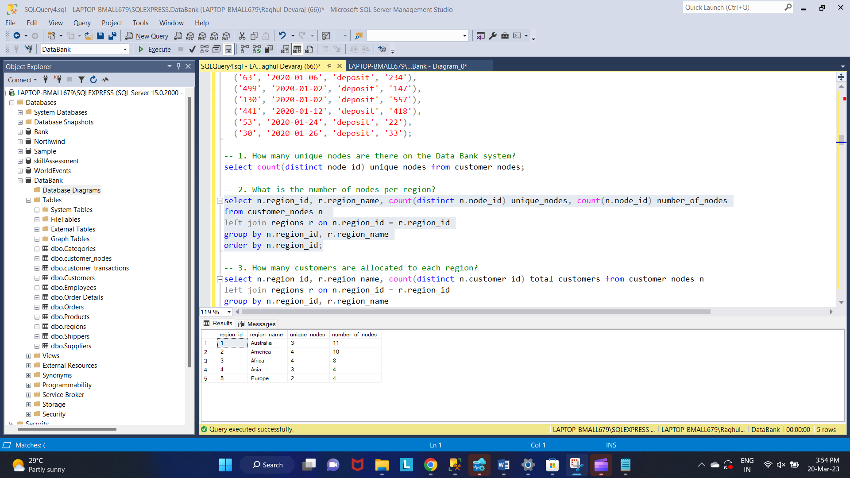

Q3. How many customers are allocated to each region?

select n.region_id, r.region_name, count(distinct n.customer_id) total_customers from customer_nodes n

left join regions r on n.region_id = r.region_id

group by n.region_id, r.region_name

order by n.region_id;

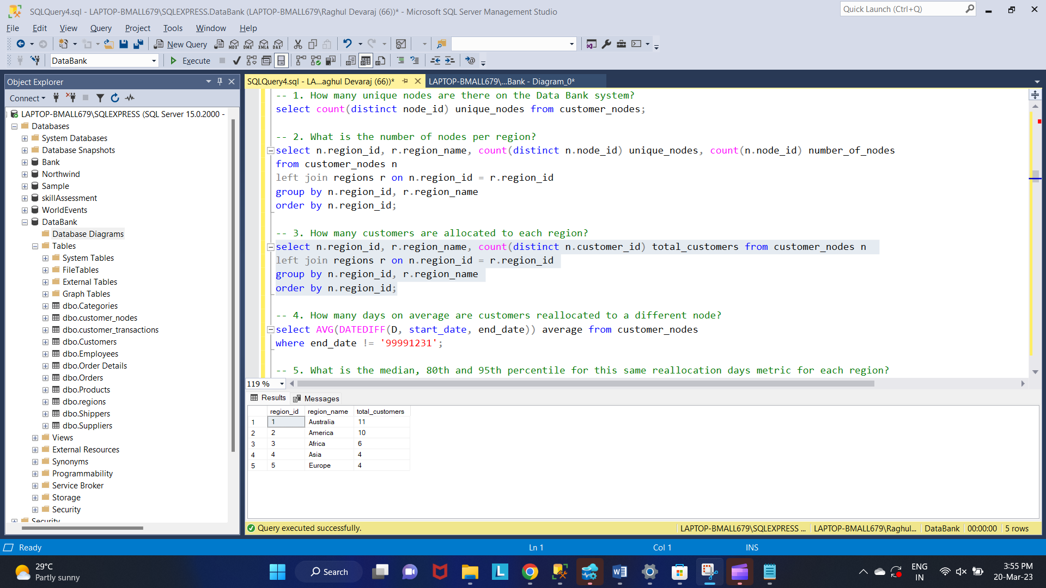

Q4. How many days on average are customers reallocated to a different node?

select AVG(DATEDIFF(D, start_date, end_date)) average from customer_nodes

where end_date != '99991231';

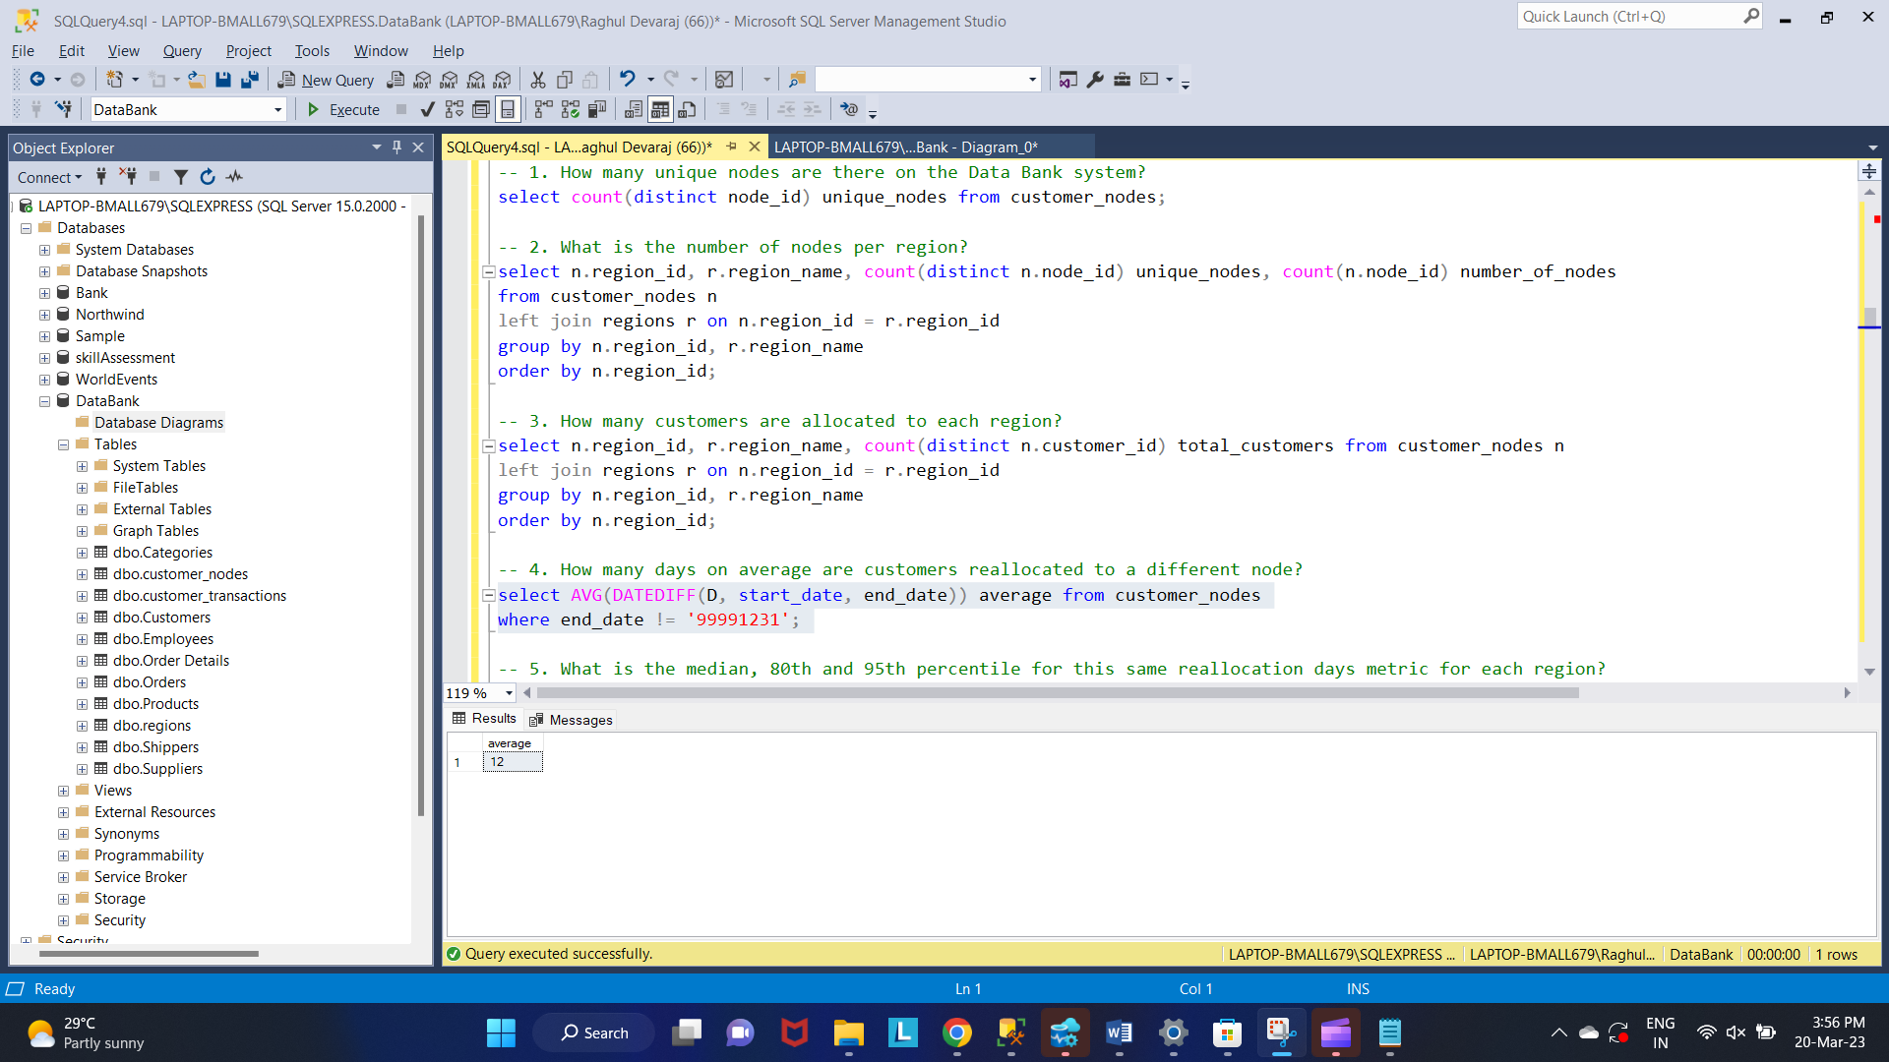

Q 5. What is the median, 80th and 95th percentile for this same reallocation days metric for each region?

WITH

diff_data

AS

(

select

n.customer_id,

n.region_id,

r.region_name,

DATEDIFF(D, n.start_date, n.end_date) diff

from customer_nodes n

left join regions r on n.region_id = r.region_id

where end_date != '99991231'

)

select distinct

region_id,

region_name,

PERCENTILE_CONT(0.5) WITHIN GROUP (ORDER BY diff)

OVER (PARTITION BY region_name) AS median,

PERCENTILE_CONT(0.8) WITHIN GROUP (ORDER BY diff)

OVER (PARTITION BY region_name) AS percentile_80,

PERCENTILE_CONT(0.95) WITHIN GROUP (ORDER BY diff)

OVER (PARTITION BY region_name) AS percentile_95

from diff_data

order by region_id;

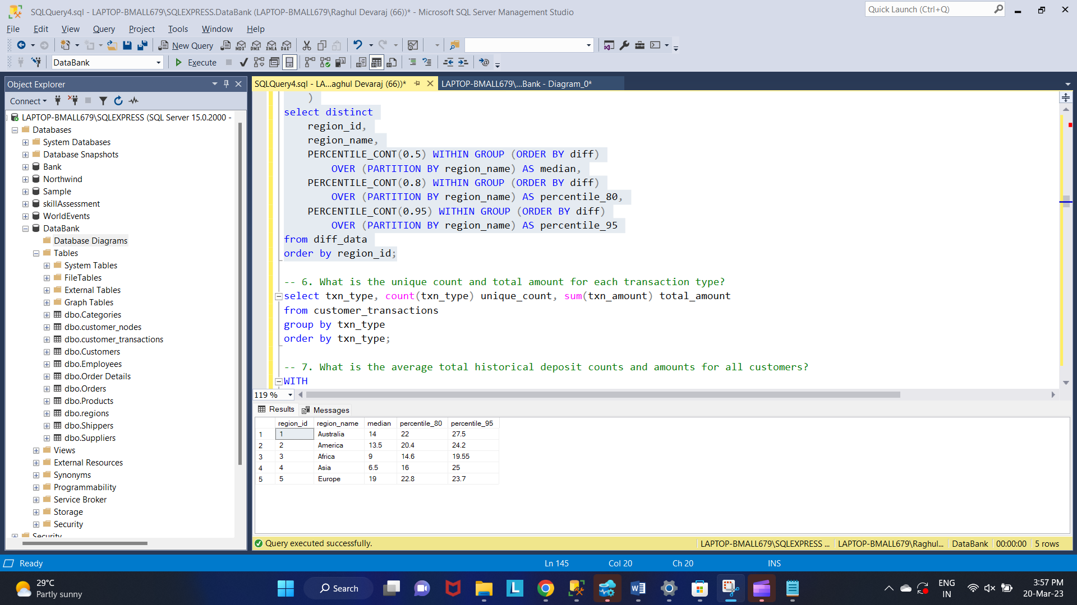

Q 6. What is the unique count and total amount for each transaction type?

select txn_type, count(txn_type) unique_count, sum(txn_amount) total_amount

from customer_transactions

group by txn_type

order by txn_type;

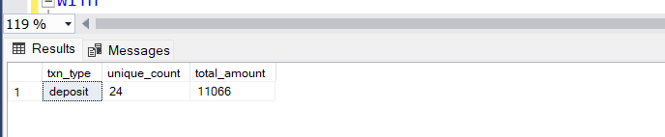

Q 7. What is the average total historical deposit counts and amounts for all customers?

WITH

historical

AS

(

select

n.customer_id,

t.txn_type,

count(t.txn_type) count,

avg(t.txn_amount) total_amount

from customer_transactions t

left join customer_nodes n on t.customer_id = n.customer_id

left join regions r on n.region_id = r.region_id

group by n.customer_id, t.txn_type

)

select

avg(count) historical_count,

avg(total_amount) total_amount

from historical

where txn_type = 'deposit';

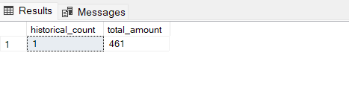

Q 8. For each month - how many Data Bank customers make more than 1 deposit and either 1 purchase or 1 withdrawal in a single month?

WITH

historical --count data each type transactions

AS

(

select

n.customer_id,

DATEPART(M, t.txn_date) month_id,

DATENAME(M, t.txn_date) month_name,

count(t.txn_type) total

from customer_transactions t

left join customer_nodes n on t.customer_id = n.customer_id

left join regions r on n.region_id = r.region_id

group by n.customer_id, DATEPART(M, t.txn_date), DATENAME(M, t.txn_date)

),

deposit

AS

(

select

n.customer_id,

DATEPART(M, t.txn_date) month_id,

DATENAME(M, t.txn_date) month_name,

sum(case when t.txn_type = 'deposit' then 1 else 0 end) deposit

from customer_transactions t

left join customer_nodes n on t.customer_id = n.customer_id

group by n.customer_id, DATEPART(M, t.txn_date), DATENAME(M, t.txn_date)

),

purchase

AS

(

select

n.customer_id,

DATEPART(M, t.txn_date) month_id,

sum(case when t.txn_type = 'purchase' then 1 else 0 end) purchase

from customer_transactions t

left join customer_nodes n on t.customer_id = n.customer_id

group by n.customer_id, DATEPART(M, t.txn_date)

),

withdrawal -- type transactions = withdrawal

AS

(

select

n.customer_id,

DATEPART(M, t.txn_date) month_id,

sum(case when t.txn_type = 'withdrawal' then 1 else 0 end) withdrawal

from customer_transactions t

left join customer_nodes n on t.customer_id = n.customer_id

group by n.customer_id, DATEPART(M, t.txn_date)

),

data -- join all data

AS

(

select

h.customer_id,

h.month_id,

h.month_name,

h.total,

d.deposit,

p.purchase,

w.withdrawal

from historical h

left join deposit d on h.customer_id = d.customer_id and h.month_id = d.month_id

left join purchase p on h.customer_id = p.customer_id and h.month_id = p.month_id

left join withdrawal w on h.customer_id = w.customer_id and h.month_id = w.month_id

)

select

month_id,

month_name,

COUNT(customer_id) customer_count

from data

where deposit > 1

and (purchase >= 1 or withdrawal >= 1)

group by month_id, month_name

order by month_id;

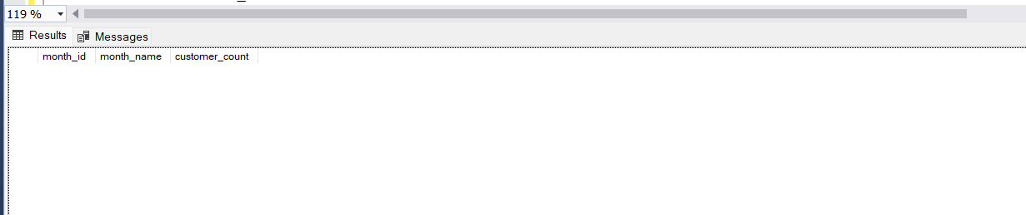

Q 9. What is the closing balance for each customer at the end of the month?

WITH

first_month

AS

(

SELECT

customer_id,

CAST('20200131' as date) closing_date,

MIN(DATEPART(M, txn_date)) min_month,

MAX(DATEPART(M, txn_date)) max_month

from customer_transactions

group by customer_id

),

months --recursive function (for closing_date)

AS

(

SELECT

customer_id,

closing_date,

DATEPART(M, closing_date) month_id,

DATENAME(M, closing_date) month_name

, min_month, max_month

FROM first_month

UNION ALL

SELECT

customer_id,

DATEADD(M, 1, closing_date) closing_date,

DATEPART(M, DATEADD(M, 1, closing_date)) closing_id,

DATENAME(M, DATEADD(M, 1, closing_date)) closing_name

, min_month, max_month

FROM months b

WHERE closing_date <= CAST('20200401' as date)

),

balance --count data each type transactions

AS

(

select

customer_id,

DATEPART(M, txn_date) month_id,

DATENAME(M, txn_date) month_name,

sum(case when txn_type in ('purchase','withdrawal') then -txn_amount

else txn_amount end) txn_amount

from customer_transactions

group by customer_id, DATEPART(M, txn_date), DATENAME(M, txn_date)

)

select

m.customer_id,

m.month_id,

m.month_name,

SUM(txn_amount) OVER(PARTITION BY m.customer_id ORDER BY m.month_id

ROWS BETWEEN UNBOUNDED PRECEDING AND CURRENT ROW) closing_balance

from months m

left join balance b on b.customer_id = m.customer_id and b.month_id = m.month_id

where m.month_id between min_month and max_month

ORDER BY m.customer_id, m.month_id;

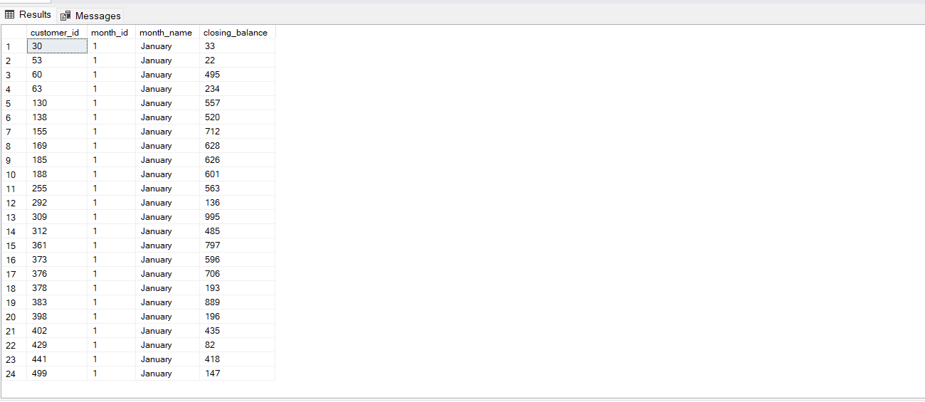

Qa10. What is the percentage of customers who increase their closing balance by more than 5%?

WITH

first_month

AS

(

SELECT

customer_id,

CAST('20200131' as date) closing_date,

MIN(DATEPART(M, txn_date)) min_month,

MAX(DATEPART(M, txn_date)) max_month

from customer_transactions

group by customer_id

),

months --recursive function (for closing_date)

AS

(

SELECT

customer_id,

closing_date,

DATEPART(M, closing_date) month_id,

DATENAME(M, closing_date) month_name

, min_month, max_month

FROM first_month

UNION ALL

SELECT

customer_id,

DATEADD(M, 1, closing_date) closing_date,

DATEPART(M, DATEADD(M, 1, closing_date)) closing_id,

DATENAME(M, DATEADD(M, 1, closing_date)) closing_name

, min_month, max_month

FROM months b

WHERE closing_date <= CAST('20200401' as date)

),

balance --count data each type transactions

AS

(

select

customer_id,

DATEPART(M, txn_date) month_id,

DATENAME(M, txn_date) month_name,

sum(case when txn_type in ('purchase','withdrawal') then -txn_amount

else txn_amount end) txn_amount

from customer_transactions

group by customer_id, DATEPART(M, txn_date), DATENAME(M, txn_date)

),

closing_balances --first and closing balances

AS

(

select

m.customer_id,

m.month_id,

m.month_name,

SUM(txn_amount) OVER(PARTITION BY m.customer_id ORDER BY m.month_id

ROWS BETWEEN UNBOUNDED PRECEDING AND CURRENT ROW) closing_balance

from months m

left join balance b on b.customer_id = m.customer_id and b.month_id = m.month_id

where m.month_id between min_month and max_month

),

balances --first balances

AS

(

select

customer_id,

month_id,

month_name,

coalesce(LAG(closing_balance) OVER(PARTITION BY customer_id ORDER BY month_id),0) opening_balance,

closing_balance

from closing_balances

),

cases --closing - opening balance

AS

(

select

customer_id,

month_id,

month_name,

opening_balance,

closing_balance,

case when opening_balance is null then cast((closing_balance - 0) as float)

else cast((closing_balance - opening_balance) as float) end diff

from balances

),

percents --percentage increase

AS

(

select *,

case when opening_balance = 0 then round(cast(diff/1*100 as float), 2)

else round(cast(diff/opening_balance*100 as float), 2) end percentage

from cases

),

minimum --when balance null then 0

AS

(

select *,

MIN(percentage) OVER(PARTITION BY customer_id) mins

from percents

)

select ROUND(100 * CAST(COUNT(customer_id) as float) /

(select count(*) from customer_transactions), 2) percentage_of_customers

from minimum

where mins > 5;

